BUCKET OPEN WAREHOUSE

1. Tidak bisa download open warehouse  
   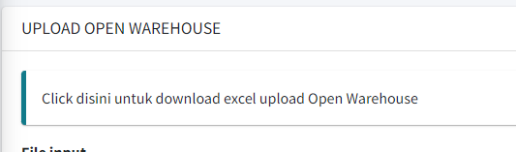
2. Tidak bisa download pending reason  
   A screenshot of a computer

   Description automatically generated
3. Download list data mapping – klik export  
   A screenshot of a data mapping

   Description automatically generated

Hasil Excel export  
Kolom A untuk versi sebelumnya ID Mapping  
Kolom E status all status bukan Cuma open warehouse  
Kolom J untuk versi sebelumnya NOTE

Untuk aplikasi masuk ke data management report memberbank setelah klik export

1. Hasil upload merchant TEST – city kosong  
   A screenshot of a computer

   Description automatically generated

Bucket Ready To Mapping

1. Tidak bisa download Ready to Mapping  
   A screenshot of a computer

   Description automatically generated

Bucket ALL DATA

1. Bucket ALL DATA – Tapi Nama Close Completed

1. Download list data mapping – klik export  
   A screenshot of a data mapping

   Description automatically generated
2. Hasil Excel export  
   Kolom A untuk versi sebelumnya ID Mapping  
   Kolom E status all status bukan Cuma open warehouse  
   Kolom J untuk versi sebelumnya NOTE  
   A screenshot of a computer

   Description automatically generated
3. Tampilan all data tidak partisi dan tidak ada ketran total datanya

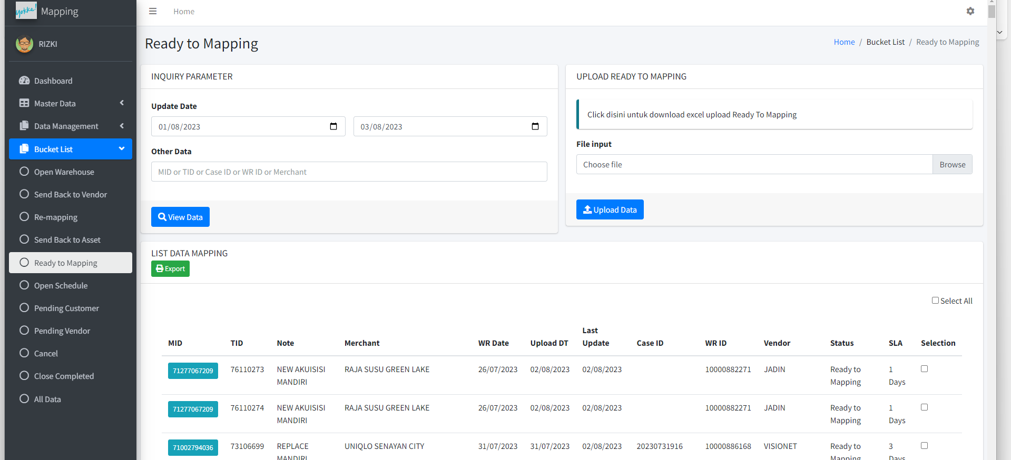

Untuk Proses Manual Mapping  
Open Warehouse – Ready to mapping – Schedule **AMAN**Open Warehouse – Ready to mapping – Schedule – Send Back Asset – Schedule **AMAN**Open Warehouse – Ready to mapping – Send Back Vendor – Ready To Mapping – Schedule **AMAN**